Maritime Museums
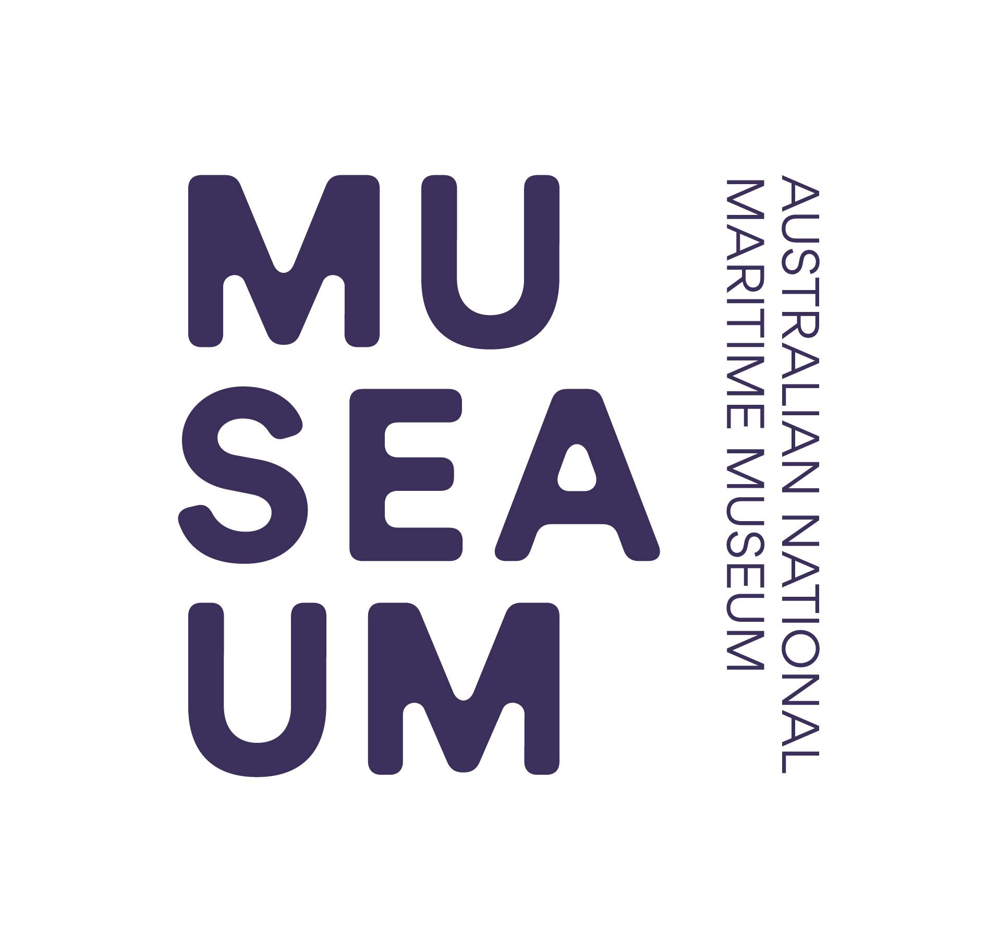

of Australia Project Support Scheme (MMAPSS)

2019 – 2020
Internship Application Form

Please complete all the relevant sections of this application form.

Please also attach any expanded answers or additional information to this application form that is either required or that you think would be useful for the MMAPSS Selection Committee when considering your application.

Please feel free to use bullet points to answer questions, wherever you find convenient, throughout the application.

Section 1 Organisation’s Details

1.1 | Name of organisation
1.2 | Name of President/Director
1.3 | Street address
1.4 | Postal address
1.5 | Phone number
1.6 | Email address
1.7 | Website address
1.8 | ABN
1.9 | Is the organisation GST registered? | YES | NO
1.10 | Is the organisation  not-for-profit? | YES | NO
1.11 | What is the name of your federal electorate?

Section 2 Internship Applicant’s Contact Details

2.1 | Title |  | Dr |  | Mr | Mrs |  | Ms | Other:
2.2 | Name
2.3 | Position within the  organisation
2.4 | Email address
2.5 | Postal address
2.6 | Home Phone number
2.7 | Work Phone number
2.8 | Mobile phone number
2.9 | Best times to reach you?  (eg Wed-Sat, 10 am to 3 pm)
2.10 | Gender |  | M F
2.11 | Emergency Contact Details:
Name
Relationship
Emergency Contact Numbers |  |  | (w)  (h)  (m)
2.12 | Workplace Diversity:
Aboriginal or Torres Strait Islander Origin (ATSIO) |  |  |  |  |  |  | YES NO
Non English speaking Background (NESB) |  |  |  |  |  |  | YES NO
Disabled |  |  |  |  |  |  | YES NO
Language/s Fluently Spoken: |  |  |  |  |  |  | YES NO
Australian Citizen |  |  |  |  |  |  | YES NO
2.13 | Medical Issues: Do you have any medical conditions that might limit your performance as a Volunteer / Intern? If so, please provide details:
2.14 | How did you find out about the ANMM MMAPSS Internship/Volunteer program?
ANMM Website |  |  |  | ANMM mail out
ANMM email promotion |  |  |  | ANMM Blog
Other (please describe):

Section 3 Organisation & its Collection

3.1 | Please tick which best describes your organisation.
Maritime Museum |  |  |  | Community Museum
Local Government |  |  |  | Indigenous group
Historical Society |  |  |  | Other:
3.2 | Briefly describe your organisation structure and list office bearers
3.3 | Provide details of visitor numbers to your organisation for the 2018 calendar year
3.4 | How many members and/or volunteers are in your organisation
3.5 | Briefly describe the history of your organisation
3.6 | Briefly describe the programs and activities of your organisation
3.7 | Describe your role and the duties you perform within your organisation
3.8 | Describe your organisation’s collection, including quantity and type(s) of material
3.9 | Does your organisation own the collection? Please circle your answer below
YES NO
3.10 |  | Does your organisation have a collection development policy?
YES – please attach a copy |  |  |  |  | NO
3.11 |  | Does your organisation have a collection preservation policy?
YES – please attach a copy |  |  |  |  | NO

Section 4 Income and Expenditure

Please note: this table is to give an overall ‘snapshot’ of your financials and the categories listed may not fit your organisation’s practices. You are welcome to attach more detailed information to your application if you wish.

4.1 | Please list your organisation’s income and expenditure for the 2017-2018 financial year.
Income |  | Amount (A$)
Government
(federal/state/local)
Private
Membership/Subscription
Admission fees
Donations
Fundraising
Funding
Other:
TOTAL
Expenditure |  | Amount (A$)
Wages
Administration
Services
Marketing and promotion
Collection Management
Exhibitions
Conservation
Insurance
GST payments
Other:
TOTAL

4.2 | Has your organisation previously applied for a MMAPSS Grant?
YES NO
4.3 | If ‘Yes’, please list the years an application was made (regardless of success).
Year:  Year: |  | Year:  Year: | Year:  Year:

4.4 | Has your organisation previously received a MMAPSS Grant?
YES NO
4.5 | If ‘Yes’, please state which year and the amount of funding received  (Please add more rows below or attach a list as required to ensure all MMAPSS grants previously received are stated.)
Year:  Amount:  Brief description of project: |  | Year:  Amount:  Brief description of project:
Year:  Amount:  Brief description of project: |  | Year:  Amount:  Brief description of project:
4.6 | Has your organisation received any other grants in the last two years? Yes/No
YES NO
4.7 | If ‘Yes’, please state which source, year and the amount of funding received. (Please add more rows below or attach a list as required to ensure all grant funding received in the last two years is stated.)
Source:
Year:
Amount:
Brief description of project:
Source:
Year:
Amount:
Brief description of project:

Section 5 Internships

You are welcome to answer questions in bullet point form where convenient. You may also attach a separate sheet of your answers if you need to.

5.1 | Please indicate whether you would like to undertake an internship at the ANMM or at another willing maritime museum. (If the internship is to be held at another maritime museum please attach a letter of support from that museum to confirm their willingness to participate.)
5.2 | How many weeks (one or two) would you like your internship to be?
5.3 | Please specify which activities you wish to participate in and/or observe during an internship.
5.4 | What specific skill(s) would you like to acquire through an internship.
5.5 | Please state which area/s of the museum would you like to work in.  You may list up to four.
5.6 | Please describe a particular project/s or object/s you are working on or would like to work on (and attach photos) which you can use as a point of discussion during your internship. For example; if you want experience in:  - Conservation: is there a specific object that you want advice on? Can you bring it with you to the ANMM?  - Exhibition Design: prepare photos of your space, challenges and plans you have to develop the space.
5.7 | What benefit will you provide to your organisation as a result of an internship?
5.8 |  | What level of skills and experience do you have in the area that you wish to work?
5.9 |  | Additional information you would like to provide about yourself, noting any other internships you may have undertaken.
5.10 | If you would like assistance with your travel and accommodation arrangements, please outline what assistance you require.
5.11 |  | Name and contact details of two referees, one from your organisation and another of your choice.
Name of 1st referee
Position title
Organisation
Phone
Email
Name of 2nd referee
Position title
Organisation
Phone
Email

Section 6 Attachments

You must attach a letter of support endorsing your application from the head of your organisation and a copy of your current resume. Please note: attachments will not be returned.
Attachment | List your attachments here:
1 | Letter of support from the head of your organisation (compulsory)
2 | Current resume (compulsory)
3
4

Section 7 Applicant Declaration

I/we, the undersigned, assure the Australian National Maritime Museum that the statements made in this application are true and correct, and that I/we have read and agree to abide by the Maritime Museums of Australia Project Support Scheme (MMAPSS) 2019 - 2020 Guidelines.

I acknowledge that if I am successful in this Internship application:
- I must complete an Australian Federal Police National Police Check (NPC) and advise the Human Resources Section Head or Volunteers Manager of any subsequent substantive changes to my criminal history.
- I may also be required to provide a Working with Children Check number if the internship is identified to have a requirement to work with children.

I also agree that any participation in the ANMM volunteers / MMAPSS Internship program creates an obligation to carry out tasks at the direction of staff and to the standards of the ANMM and that I will be required to complete the ANMM’s online work experience and internship induction modules.

I understand that I am engaged as a volunteer intern by the ANMM and either party can end the arrangement at will.

I have declared all information that might prevent me from doing any agreed tasks in a satisfactory way.

7.1 | Head of organisation.
Title |  | Dr | Mr | Mrs | Ms | Other:
Full name
Position within organisation
Date
Signature
7.2 | Internship applicant
Title |  | Dr | Mr | Mrs | Ms | Other:
Full name
Position within organisation
Date
Signature

Section 8 Checklist

- Complete all relevant sections of the Internship Application Form.
- Obtain all necessary approvals and signatures. Unsigned applications are invalid and will not be assessed.
- Attach a letter of support for your internship from the Head of your organisation and a copy of your current resume.
- If your organisation is not registered for GST, you may wish to consult a financial adviser about the implications of receiving MMAPSS funding.
- Make copies of all supporting documentation that you attach to your application, as attachments will not be returned.

All applications must be received by the Australian National Maritime Museum by 31 March 2019.

Applications should be addressed to:

Via Email:
Applicants are encouraged to submit applications to the MMAPSS Coordinator via email to mmapss@sea.museum. Applicants submitting electronic applications must ensure signatures are in place on the application.

OR Via Mail:
The MMAPSS Coordinator
Australian National Maritime Museum
58 Pirrama Road
PYRMONT NSW 2009

