Maritime Museums
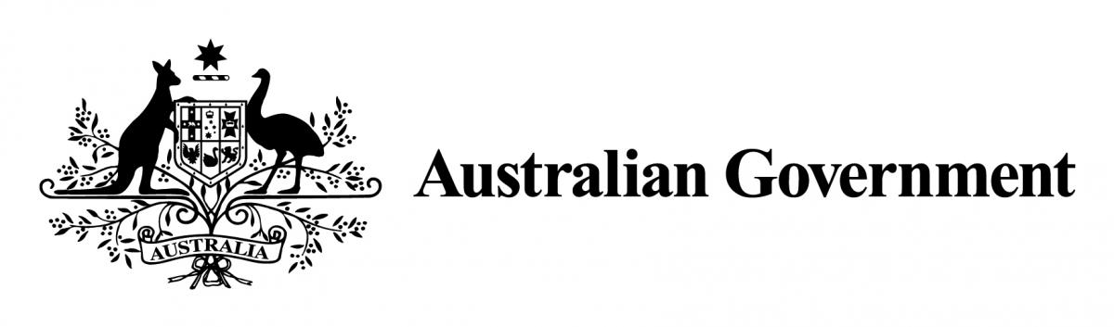
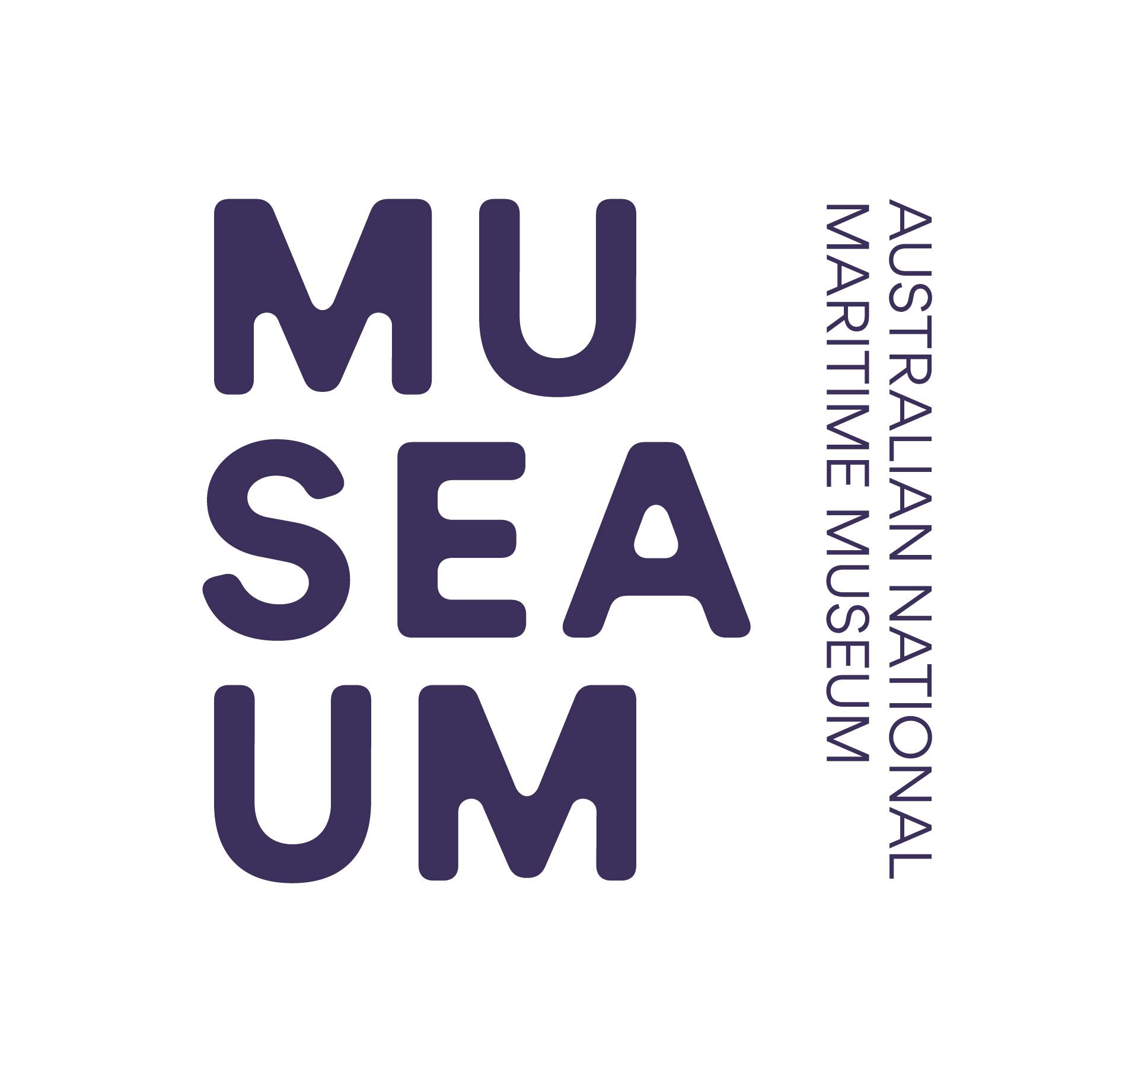

of Australia Project Support Scheme (MMAPSS)

2021 – 2022
Internship Acquittal Template

Please use this template as a guide to completing your acquittal. As per the MMAPSS Guidelines the final report must contain:

- a description of the internship as completed;
- a photographic record of the internship where appropriate;
- an evaluation of how the objectives of the internship were achieved;
- an assessment of the value of the funding to the internship;
- a financial acquittal statement detailing the total cost of the internship and expenses being claimed.
- a publicity and media report which details formal acknowledgement of the
Australian Government and the ANMM in relation to the project, including copies of any related media coverage, web coverage or other promotional material.

Please be sure to attach all receipts, or certified copies, related to your acquittal.
Failure to do so may result in ineligibility for future funding.
Feel free to attach expanded answers or additional information to this application form.

Section 1 Organisation’s Details

1.1 | Name of organisation
1.2 | Name of President/Director
1.3 | Street address
1.4 | Postal address
1.5 | Phone number
1.6 | Email address
1.7 | Website address

Section 2 Internship Recipients’ Contact Details

2.1 | Title | Dr | Mr | Mrs | Ms | Other:
2.2 | Name
2.3 | Position within the  organisation
2.4 | Email address
2.5 | Postal address
2.6 | Phone number
2.7 | Mobile phone number
2.8 | Best times to reach you?  (eg Wed-Sat, 10 am to 3 pm)

Section 3 MMAPSS Internship

3.1 | A description of the internship as completed;  - Briefly describe your internship.  - Include a photographic record of the internship where appropriate
3.2 | An evaluation of how the objectives of the internship were achieved. i.e.;  - Describe your reasons for applying for an internship and your objectives in undertaking it.  - What specific skill(s) did you acquire through the internship?
3.3 | An assessment of the value of the internship to your parent museum
3.4 | Explain any unexpected problems encountered.
3.5 | In what ways did you meet your overall objectives? If you did not meet your objectives, please explain why.
3.6 | Please comment on the value of the MMAPSS support for the internship

Section 4 Income and Expenditure

4.1 | Please list all forms of funding used to complete this internship
Income |  |  | Amount (A$)
MMAPSS Grant
Applicant’s Contribution
Government
TOTAL
4.2 | Please list internship related expenses  (attach certified invoices and / or receipts to prove the total expenditure).  Please create and attach a list of expenses being claimed i.e.:
Item / description |  | Supplier |  | Amount Claimed
Total Amount Claimed |  |  |  | $
4.3 | Complete the ANMM Finance Team’s online form to set you up as a New Creditor  In the payment system details so that an electronic funds transfer (EFT) can be arranged by ANMM Finance to reimburse claimed expenses  Local Creditor Set Up Request

Section 5 Publicity and Media Report

5.1 | Describe any ways you have promoted your internship (optional).
5.2 | If you have promoted your internship, please list the types of media & publicity engaged for your internship, i.e. print media (magazines, local papers), web coverage and other promotional material)
5.3 | If you have promoted your internship, provide details of formal acknowledgement of the Australian Government and the ANMM in relation to the internship. Please attach copies.

Section 6 Blog Post

On completion of the internship, and by 31 August 2022, you are invited to provide an article for publication on the ANMM blog www.sea.museum/discover/blog or the stories page of the ANMM the website www.sea.museum/about/grants-and-awards/funding-for-maritime-heritage/stories. The article should be up to 300 words and outline the internship experience, how participation was of benefit to you and your organisation. Submissions will need to include images ideally 3MB or larger to allow for use in print media as required.

The MMAPSS Coordinator will provide a guide to blogging. Alternatively, you can request that a list of Q&A style questions be prepared for you to assist you to get started.

Please let the MMAPSS Coordinator know if you would like to write a blog post.

Section 7 Attachments

You must attach a financial acquittal statement and original invoices or receipts or certified copies of invoices or receipts for internship costs.
Please note that attachments will not be returned.

Attachment | List your attachments here:
1 | i.e. Letter from the Head of your Organisation acknowledging the internship as complete (compulsory)
2
3
4
5

Section 8 Applicant Declaration

I/we, the undersigned, assure the Australian National Maritime Museum that the statements made in this acquittal are true and correct, and that I/we have read and abided by the Maritime Museums of Australia Project Support Scheme (MMAPSS) 2021 - 2022 Guidelines.

8.1 | Head of organisation.
Title |  | Dr | Mr | Mrs | Ms | Other:
Full name
Position within organisation
Date
Signature
8.2 | Contact person
Title |  | Dr | Mr | Mrs | Ms | Other:
Full name
Position within organisation
Date
Signature

All acquittals must be received by the Australian National Maritime Museum by
31 August 2022.

Acquittals should be addressed to:

The MMAPSS Coordinator
Australian National Maritime Museum
58 Pirrama Road
Pyrmont NSW 2009

Or via email to mmapss@sea.museum

