Maritime Museums
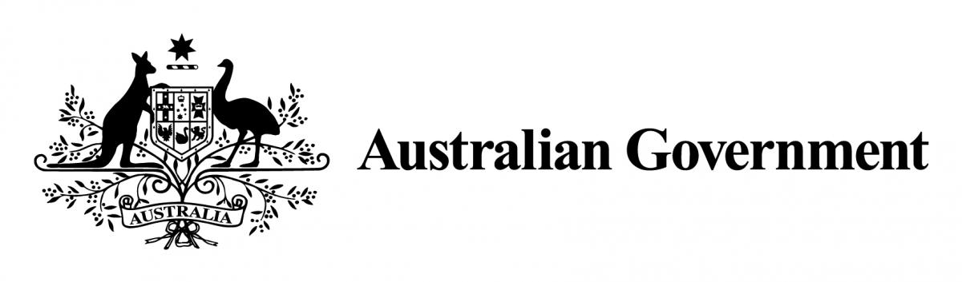
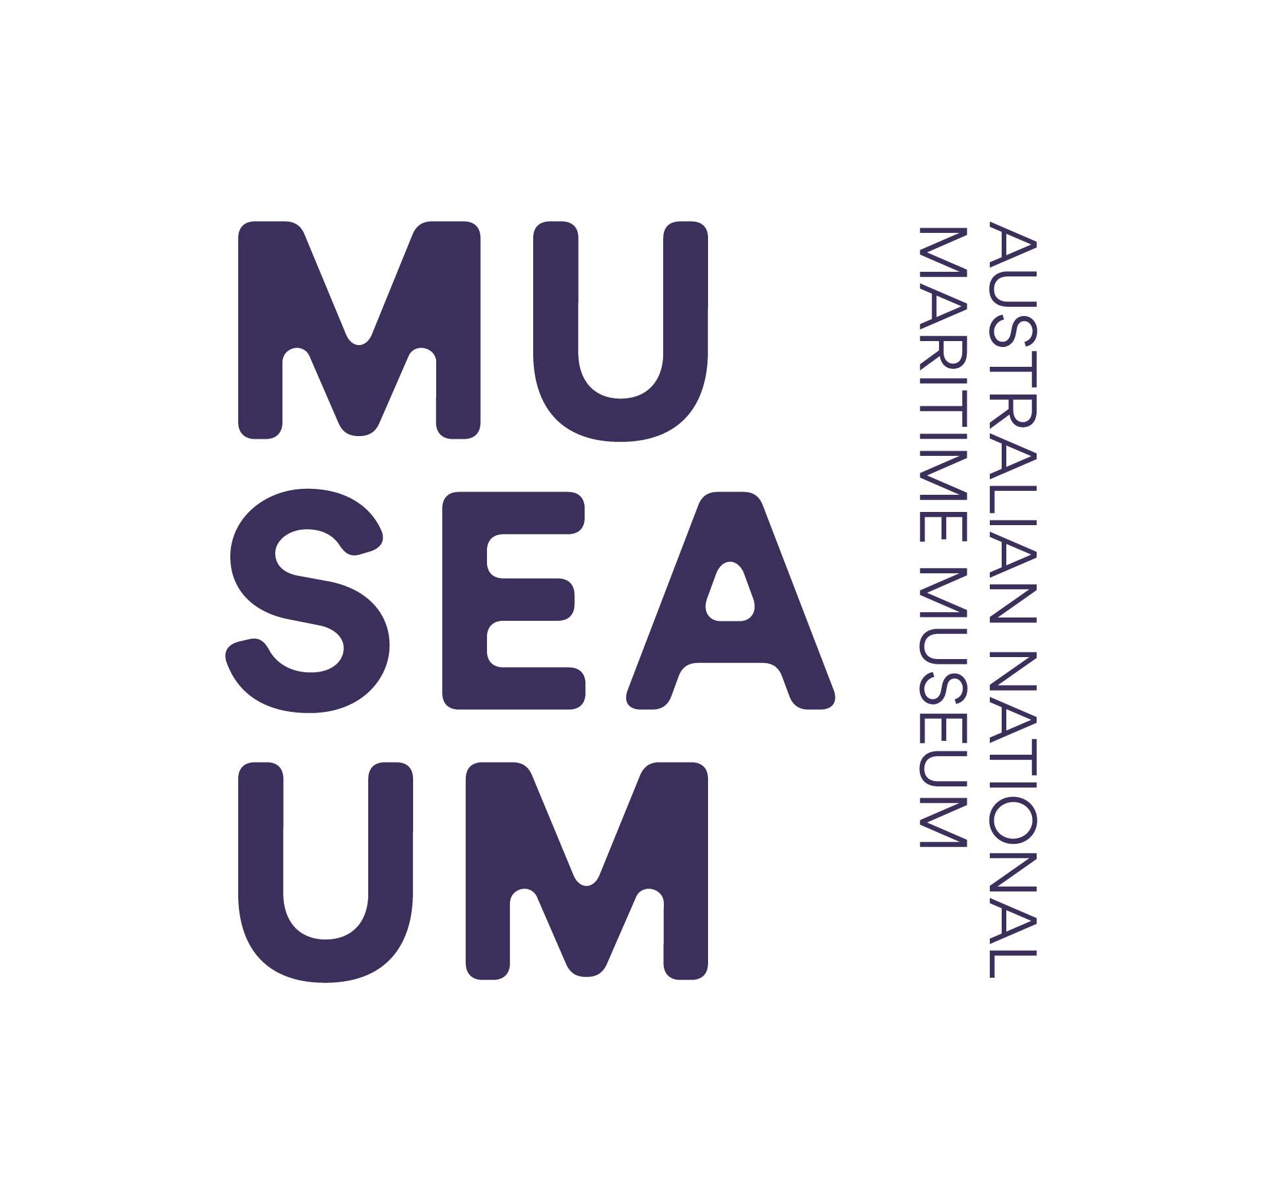

of Australia Project Support Scheme (MMAPSS)

2020 – 2021
Guidelines

2020 Support for Bushfire affected organisations:

In support of those organisations affected by the summer of 2019-20 bushfire crises across the country, a priority weighting will be given by the Selection Committee to applications submitted by these organisations.

To demonstrate that your organisation has been affected by the summer of 2019-20 bush fires, please include details in the letter of support from the Head of your organisation which outline how the bush fires have affected your organisation.

If in the judgement of the Selection Committee the organisation submitting an application has been affected by the summer of 2019-20 bush fires an extra point will be given against each of the following selection criteria:

- Relevance to a specified target audience & the community in general
- Quality of the project in terms of its aims, content, rationale and likely benefit

Projects and applications will still need to abide by the MMAPSS eligibility criteria.
As always, MMAPSS is open to applications for cash grants, in-kind (non-cash) support and internships.

Applicants from organisations which have not been affected by the summer of 2019-20 bush fires are strongly encouraged to apply as usual.

For more information, a Q&A about this is available at: www.sea.museum/grants

Introduction

The Maritime Museums of Australia Project Support Scheme (MMAPSS) was established in 1995 and provides funding support to incorporated not-for-profit organisations caring for Australia’s maritime heritage. MMAPSS is jointly funded by the Australian Government and the Australian National Maritime Museum (ANMM) and managed by the ANMM with the support of the Ministry for the Arts.

Objective

The objective of MMAPSS is to assist eligible organisations to:
- develop and implement objectives for collecting, managing, organising, preserving, conserving and communicating objects and/or collections of maritime significance;
- undertake projects that will increase standards of practice for the care and management of maritime objects and/or collections of significance; and
- provide quality public access to objects and/or collections of maritime significance through display, interpretation and community involvement.

Projects

Funding of up to $15,000 is available to eligible organisations for projects that will increase standards of practice for the care and management of maritime objects and/or collections of significance. The object or collection must contribute to an understanding of Australia, its people and developments which have influenced its maritime history.

The Selection Committee will evaluate each project application against the following selection criteria:
- evidence of the project’s maritime significance*;
- quality of the project in terms of its aims, content, rationale and likely benefit;
- evidence of sound planning, appropriate management and financial
administration;
- relevance to a specified target audience and the community in general; and
- demonstrated viability of the organisation and the proposed project.

*For information about conducting significance assessments and developing a statement of significance, refer to the Collections Council’s publication: Significance 2.0 which can be viewed online at: http://www.arts.gov.au/resources-publications/industry-reports/significance-20

Applications that seek funding for the purchase of equipment, computer hardware or software, printing, object cases or signage will be given a low priority.

Publishing projects where access rights are limited or restricted by the owner of those rights will not be supported.

Applications for projects with an education focus and or which involve intellectual development and input will be given a high priority. Preference will also be given to applications that can demonstrate good and effective planning.

Joint submissions are encouraged with one or more organisations, and applicants may submit an application for more than one project although each organisation is only eligible for one MMAPSS project grant per year.

Funding for projects will be awarded to cover a 12 month period from 1 July 2020 to 30 June 2021 for projects beginning in or after 30 June 2020. Funding can not be used for costs incurred before this date.

Applications that seek funding for the reformatting of original material in their maritime collection including audio-visual and digitisation projects should consider the following requirements and specify the outcomes to be achieved:
- How will the project enable easier access to the collection.
- What is proposed for the original objects after digitisation.
- What technical standards will be used to digitise the photographs, video or
audio material into a file.
- The project must comply with Australian copyright law.

The ANMM will require copies of documents, files (i.e. video and photographic) and software commissioned under the MMAPSS grant to be submitted with the final report to increase accessibility for the purposes of recordkeeping, education, exhibitions, advertising, promotional materials, online usage, and for research and study.

Internships

Funding of up to $3,000 on an acquittal basis is available to support the accommodation and travel costs of internships to develop museological skills and knowledge to increase standards of practice for the care and management of maritime collections.

Internships are for up to two weeks and must be undertaken at a time that is agreed to by the ANMM. Applicants may choose to undertake internships from any area of maritime museum operation including conservation, curatorial, temporary exhibitions, registration, fleet services, external relations, education and visitor programs, members and volunteer management, library, front of house, design or marketing.

Depending on the needs and requirements of a prospective intern, a placement at a major collecting institution other than the ANMM, may be arranged.

Interns will work within the agreed department/s and will be supervised by a section head. Selection of interns and the schedule created for successful interns will take into account the ANMM’s, or other host organisation’s, resources and availability to accommodate and supervise the intern. Internships may be scheduled to be undertaken as part of a group of interns.

The Selection Committee will evaluate each internship application against the following selection criteria:

- evidence of value and relevance to the applicant and the applicant’s organisation;
- quality of the internship in terms of its aims, objectives and rational; and
- evidence of applicant’s current skills and the skills to be achieved through the internship.

The Selection Committee will give preference to applications that:

- apply to work at least one week in one particular department of the ANMM;
- demonstrate the goal of achieving defined skills and experiences; and
- clearly identifies the objectives and milestones of the proposed internship.

During the period of placement interns will be required to comply with all reasonable directions issued by the Museum and to conform to all existing policies, procedures and work practices including Work Health and Safety. It is a condition of placement that interns complete an Australian Federal Police National Police Check (NPC) (paid for by the ANMM). Interns may also be required to provide a Working With Children Check number if the internship is identified to have a requirement to work with children.

Eligibility

To be eligible an organisation must:
- be an Australian legally incorporated not-for-profit organisation, such as a museum, historical society, or community based organisation;
- be actively involved in collecting, preserving, interpreting and exhibiting Australia’s maritime heritage; and
- have a collection that is accessible to the public.

An organisation is not eligible if:
- the collection is privately owned;
- the collection is not accessible to the public, such as a club where access is restricted to members only;
- it is a major national, state or territory collecting institution; or
- it has an outstanding acquittal from a previous MMAPSS grant.

MMAPSS provides funding support for projects and internships that would not be eligible for other sources of funding. Projects and internships deemed eligible to apply for other funding schemes will be considered a low priority.

Assessment process

Applications will be assessed in May 2020 by the MMAPSS Selection Committee which comprises representatives from the Department of Infrastructure, Transport, Regional Development and Communications, the ANMM and the maritime heritage community. The Selection Committee’s decision is final.

On the basis of the Selection Committee’s assessments, applications will be short-listed, ranked and recommendations for funding will be made. Funding will be awarded to as many of the highest ranking applications as funds will allow. Subject to the availability of funds and the recommendations of the Selection Committee, only partial funding of the amount requested may be awarded. The ANMM may award funding based on a modified project outcome.

Information about the status of applications will not be released until all applications have been assessed and final decisions reached. All applicants will receive written and/or email notification of the outcome of their applications by 30 June 2020.

Acquittal

An acquittal template for the final report will be provided to recipients and a sample is available at www.sea.museum/grants. In all cases projects and internships must be completed and acquitted by 30 June 2021.

By submitting an application and on completion of the projects and internships, recipients undertake to provide a full written final acquittal report on the project or internship, including a financial acquittal statement with original receipts or certified copies of receipts for project or internship costs (where certified means certification by a Justice of the Peace). Failure to supply documentation may result in the grant being terminated (refer also Termination of funding, pg.6). The completion date of projects and internships will be determined in consultation with the funding recipient. This consultation will also determine whether a progress report will be required.

The final report must contain:

- a description of the project or internship as completed;
- a photographic record of the project or internship where appropriate;
- an evaluation of how the objectives of the project or internship were achieved;
- an assessment of the value of the funding to the project or internship;
- a financial acquittal statement detailing the total cost of the project or internship, how the funding was used, and details of any funding provided by other bodies. This must include original receipts or certified copies of receipts for project or internship costs (where certified means certification by a Justice of the Peace)
- a publicity and media report which details formal acknowledgement of the Australian Government and the ANMM in relation to the project. (refer also Acknowledgement and publications, pg.6)
- copies of any documents, media files or software commissioned under the MMAPSS grant as required in the letter of offer.

Blog Post

By submitting an application recipients are invited to provide a 300 – 1200 word submission for the ANMM blog www.sea.museum/discover/blog or the ANMM Website stories www.sea.museum/about/grants-and-awards/funding-for-maritime-heritage/stories. Submissions will need to include images ideally 3MB or larger to allow for use in print media as required. If recipients would like to take the opportunity to promote their project and share their experience with other similar organisations, the blog post could detail the project or internship, provide an assessment of the value of the funding, and emphasise the long term outcomes of the project. Guidance and assistance will be given to writers of the blog post by the MMAPSS Coordinator and ANMM digital curators.

How to Apply

Eligible applicants are required to complete an application form for projects and internships for MMAPSS funding.

For Project applicants there are two options for submitting an application.

- Online Application form: An online application form is available for projects. The ANMM’s preference is that project applications are submitted using this online system. The online form can be accessed by following the link at www.sea.museum/grants Applicants will be required to create a login to the online system.

- Applications will also be accepted via the downloadable word document.
If this option is chosen, applicants are encouraged to submit applications by email to mmapss@sea.museum. Applicants submitting applications by email must ensure signatures are in place on the application.

Internship applicants are required to complete the Word document. Internship applications are not available via the online system in this round. Internship applicants are encouraged to submit applications by email to mmapss@sea.museum. Applicants submitting applications by email must ensure signatures are in place on the application.

Submissions must be received by the ANMM no later than 1 May 2020 for funding in the financial year 2020 - 2021. Application details are available from the ANMM via its web site or by email.

An email will be sent to acknowledge the application has been received.

Conditions of funding
Accountability
The MMAPSS funding is available through public money and funding recipients are accountable to the ANMM for the proper use of the funding provided. Failure to comply with the conditions may result in future funding requests being declined.

Commonwealth Child Safe Framework – Statement of Compliance
If the project or any part of the project or internship activity involves the receipent
employing or engaging a person (whether as an officer, employee, contractor or
volunteer) that is required by State or Territory law to have a working with
children check to undertake the Activity or any part of the Activity, the receipient
agrees:

- to comply with all State, Territory and Commonwealth law relating to the employment or engagement of people who work or volunteer with children in relation to the Activity, including mandatory reporting and working with children checks however described; and

- if requested, provide the Commonwealth, at the Grantee’s cost, with an annual statement of compliance in such form as may be specified by the Commonwealth.

Formal acceptance
Recipients undertake to sign a duplicated letter of offer from the ANMM detailing the terms and conditions, and return one signed copy of the letter to the ANMM. Payment cannot be made until the ANMM receives the signed copy. This signed copy must be received by the ANMM within fifteen (15) days of the date of the letter of offer or withdrawal of the funding may occur without further notice.

Under the GST regulations recipients are required to quote their Australian Business Number (ABN), unless they can claim exemption.

Recipients registered for GST, must issue a tax invoice for the whole amount of the grant plus the GST applicable added to it. This invoice must accompany the signed letter for payment of the grant.

Purpose of funding
Projects and internships must be completed as outlined in the original application, or where applicable, as modified by the ANMM.

Project expenses must not be invoiced to an office holder of the organisation receiving the grant (see also Termination of funding below). Funds cannot be used for the payment of salaries and wages or to pay for services provided by a person who holds a position with the recipient organisation. Funding cannot be used for the acquisition of objects. Funds must be expended and projects and internships completed by 30 June 2021.

If at the completion of the project any funds remain unexpended the recipient is required to return the funds to the ANMM. In exceptional circumstances approval may be given based on a written proposal for the funds to be used to extend the original scope of the project. If approval is not given or should the recipient choose not to use any remaining funds, the recipient undertakes to return these to the ANMM within 30 days.

Alterations to the project
The ANMM will detail the terms and conditions, including any required modifications to the original project application, in the letter of offer. The ANMM will require copies of documents, files (i.e. video and photographic) and software commissioned under the MMAPSS grant to be submitted with the final report. Any significant alteration to the original application must be approved by the ANMM. Changes to the details of the approved project must be agreed to in writing by the ANMM before any grant money can be allocated towards it.

Termination of funding
Funding may be terminated by the ANMM in writing if the conditions of the funding are not observed. If funding is terminated, the recipient undertakes to return any unexpended funds to the ANMM within 30 days.

Visits and publicity
Staff of the ANMM may visit sites where MMAPSS projects are being or have been carried out. The ANMM may also use details of projects in any of its publicity. The ANMM has the right to publicise the project including the right to request and reproduce written / pictorial content for promotional / non-commercial purposes. The recipient undertakes to ensure the Australian Government and the ANMM are formally acknowledged in all media and publicity relating to the project.

Acknowledgment and publications
In all publications, promotional material and activities relating to the funded projects and internships, recipients must acknowledge the financial support it has received from the Australian Government. The appropriate acknowledgement is:

“The Maritime Museums of Australia Project Support Scheme is funded by the Australian Government through the Australian National Maritime Museum and the Department of Infrastructure, Transport, Regional Development and Communications.”

Further enquiries

For further information and/or assistance with completing an application please contact the MMAPSS Coordinator:

Australian National Maritime Museum:
58 Pirrama Road
PYRMONT NSW 2009
Tel: 02 9298 3743
Email: mmapss@sea.museum
Internet: www.sea.museum/grants

