Maritime Museums
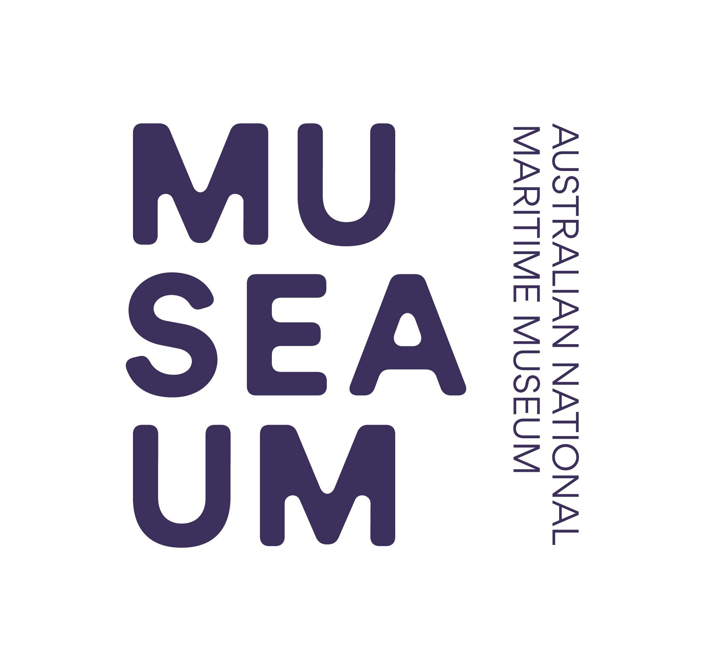

of Australia Project Support Scheme (MMAPSS)

2021 – 2022
Project Application Form

An online application form has been developed for projects. The ANMM’s preference is that project applications are submitted using the online system. The online system can be accessed by following the links at www.sea.museum/grants. You could start by using this form as a template and then transfer any information you have prepared to the online version.

Applications will also be accepted using this application form. Please complete all the relevant sections of this application form. Please attach any expanded answers or additional information to this application form that is required or that you think would be useful for the MMAPSS Selection Committee when considering your application.

Section 1 Organisation’s Details
1.1 | Name of organisation
1.2 | Name of President/Director
1.3 | Street address
1.4 | Postal address
1.5 | Phone number
1.6 | Email address
1.7 | Website address
1.8 | ABN
1.9 | Is the organisation GST registered? | YES | NO
1.10 | Is the organisation  not-for-profit | YES | NO
1.11 | What is the name of your federal electorate?

Section 2 Contact Person for this Application
2.1 | Title | Dr | Mr | Mrs | Ms | Other:
2.2 | Name
2.3 | Position within organisation
2.4 | Email address
2.5 | Postal address
2.6 | Phone number
2.7 | Mobile phone number
2.8 | Best times to reach you?  (eg Wed-Sat, 10 am to 3 pm)

Section 3 Project

3.1 | Please tick which area your project relates to.
Collection Management (inc registration, documentation and storage)
Conservation (inc preservation, vessel restoration, conservation work/treatments and professional assessments)
Presentation (inc research, development of exhibitions, establishing interpretive displays and workshops)
Development of relevant education or public programs which make collections more accessible to audiences
3.2 |  | Project title
3.2a |  | Project Executive Summary  (please summarise your project & the funding requested in 200 words or less)
3.3 |  | Project description

Milestones
Project milestones indicate how you are going to execute the project, the time frame you are working within and demonstrate your sound planning abilities. Please use this table to specify the critical tasks your project requires.

3.4 | Project milestones table.
Project Milestone Number |  | Critical Path Tasks | Date Required By
1
2
3
4
5

Budgets
When filling out the project budget table, please include a full and considered break down of all expenses and income relevant to your project. You can attach a separate budget document if you wish. Please do not simply summarise multiple project costs with a single figure. For example; for a vessel restoration, do not simply write ‘restoration; $15,000’, rather; ensure that you demonstrate clear and considered planning by detailing as much as possible a specification for the works to be completed and funded. Where possible, source quotes and attach them to this application, this will be highly regarded by the Selection Committee as a clear demonstration of commitment to the project and effective planning. In some cases, funding may not be released until these are provided. Be sure to note all in-kind support you will receive, both in goods and services, and clearly state exactly for which items you are seeking MMAPSS financial support. Please check the Guidelines, or consult the MMAPSS Coordinator to ensure the component of the project you are seeking funding assistance for is eligible. Remember that funds cannot be used for the payment of salaries and wages or to pay for services provided by a person who holds a position with the recipient organisation. Funding cannot be used for the acquisition of objects and funding cannot be used for costs incurred before 1 August 2021.

3.5 | Project budget table. *List amounts inclusive of GST.
 |  | A | B | C | D
Task, Activity or Materials |  | Applicant’s Contribution | Other Contributions | MMAPSS Funding Request | Project Total  [A+B+C]
TOTAL

3.6 | Total of MMAPSS funding requested* | $
Please note:
- If you are awarded a grant the funding will be stated as an amount without GST.
- If your organisation is registered for GST the funding amount actually paid will have GST added to it (i.e. $10,000 grant awarded plus $1,000 GST = $11,000 paid).
- If your organisation is not registered for GST the funding amount paid will not have GST added to it. (i.e. $10,000 grant awarded = $10,000 paid)

Section 4 Significance

As noted in the MMAPSS Guidelines, your application is assessed, scored and ranked against five criteria - the most important being Significance. It is advisable you consult the Collections Council of Australia publication Significance 2.0 for guidance in answering the following questions. Another useful publication to assist the Significance assessment process is Sharing our stories - Guidelines for Heritage Interpretation Chapter 5.

These questions are to help you decide what is special about the object/collection to which your project relates. Your object/collection should fit into one or more of the primary significance criteria listed.

Primary Criteria
4.1 | Historic significance  Has the object/collection been associated with people or events that have contributed to maritime history in any of the following areas?  Please tick which, if any, best applies
Local/Community |  |  | Industry/Commerce/Trade
Sport/Recreation |  |  | Exploration
Navy/Military |  |  | Aboriginal and Torres Strait Islander* (see section 4.10)
Immigration |  |  | Other
4.2 | Artistic or Aesthetic significance  Is the object/collection a rare or significant example of any of the following?  Please tick which, if any, best applies
Design, Craft or Manufacture |  |  | Style, Artistic movement or an Artist’s work
Innovative or Original |  |  | Beautiful or pleasing object
Creative or Technical achievement |  |  | Depiction of a subject, person, place or event of importance
4.3 | Scientific or Research potential  Can the object/collection teach us about some aspect of maritime history or technology? Please tick which, if any, best applies
Local/Community |  |  | Industry/Commerce/Trade
Sport/Recreation |  |  | Exploration
Navy/Military |  |  | Aboriginal and Torres Strait Islander
Immigration |  |  | Design/Technology/Manufacture
4.4 | Social or Spiritual significance  Does the object/collection have some other special value to a community or group because of an association with any of the following?  Please tick which, if any, best applies
Written, photographic, film or audio work |  |  | Educational
Memorial |  |  | Cultural
Spiritual |  |  | Social
Promotional |  |  | Other
Comparative Criteria
4.5 | Provenance  is the object/collection:
Well documented or recorded?
Is it known who created, made, owned or used the object/collection
Is there a known chain of ownership?
4.6 | Rarity or Representativeness  Is the object /collection:
A particularly fine example of its type?
One of a kind or rare?
Have unusual qualities that distinguish it from others of its type?
4.7 | Condition or Completeness  Is the object/collection:
In good condition?
Intact or complete?
Display material evidence of the way it was used?
4.8 | Interpretive Capacity  Does the object/collection:
Relevant to your organisation’s aims, collection policy and/or programs?
Hold a special place in the collection?
Help interpret aspects of its place or context?
4.9 | Please expand on the answers you have provided in questions 4.1 to 4.8 to write a statement of significance about the object(s) or collection(s) for which MMAPSS funding is requested.
4.10 | If your project relates to object(s) or collection(s) of Aboriginal and Torres Strait Islander significance please demonstrate that your organisation has obtained acknowledgment, involvement and consultation from the relevant Aboriginal and Torres Strait Islander community or local aboriginal land council. You must attach a letter of support and endorsement for the project from this community to this application.

Section 5 Organisation’s Collection

5.1 | Please tick which best describes your organisation.
Maritime Museum |  |  | Community Museum
Local Government |  |  | Aboriginal and Torres Strait Islander group
Historical Society |  |  | Other

5.2 | Briefly describe your organisation structure and list office bearers
5.3 | Provide details of visitor numbers to your organisation for the 2020 calendar year
Please only complete the following three questions (5.4 – 5.6) if your project relates to an education or public program.
5.4 |  | Describe your organisations reach to the public and or schools.  (Please list the schools / region that your organisation reaches and describe the extent of engagement you currently have with them.)
5.5 |  | How many school students visit your organisation each year?
5.6 |  | Do you have an existing education and or public program?
5.7 | How many members and/or volunteers are in your organisation
5.8 | Briefly describe the history of your organisation
5.9 | Briefly describe the programs and activities of your organisation
5.10 |  |  | Describe your organisation’s collection, including quantity and type(s) of material
5.11 |  |  | Does your organisation own the collection (including the objects involved in this Project)? Please circle your answer below
YES NO
5.12 |  |  | If ‘NO’, you must submit a joint application with the approval of the collection’s legal owner, whose contact details you must enter below.
* Please note: The legal owner or a person representing the legal owner of the collection must also co-sign the Applicant Declaration.
5.13 |  |  | Does your project relate to object(s) or collection(s) of Aboriginal and Torres Strait Islander significance? Please circle your answer below
YES NO
5.14 |  |  | If ‘YES’, you must demonstrate that your organisation has obtained acknowledgment, involvement and consultation from the relevant Aboriginal and Torres Strait Islander community and / or local aboriginal land council, whose contact details you must enter below.
* Please note: You must attach a letter of support and endorsement for the project from this community to this application.
5.15 |  |  |  | Does your organisation have a collection development policy?
YES – please attach a copy |  |  |  |  | NO
5.16 |  |  |  | Does your organisation have a collection conservation policy?
YES – please attach a copy |  |  |  |  | NO
5.17 |  |  |  | If your project is for the conservation of a vessel - does your organisation have a vessel management plan or a conservation management plan?
YES – please attach a copy |  |  |  |  | NO

Section 6 Income and Expenditure

Please note: this table is to give an overall ‘snapshot’ of your financials and the categories listed may not fit your organisation’s practices. You are welcome to attach more detailed information to your application if you wish.

6.1 | Please list your organisation’s income and expenditure for the 2019-20 financial year.
Income |  | Amount (A$)
Government
(federal/state/local)
Private
Membership/Subscription
Admission fees
Donations
Fundraising
Funding
Other
TOTAL
Expenditure |  | Amount (A$)
Wages
Administration
Services
Marketing and promotion
Collection Management
Exhibitions
Conservation
Insurance
GST payments
Other
TOTAL

6.2 | Has your organisation previously applied for a MMAPSS Grant?
YES NO
6.3 | If ‘Yes’, please list the years an application was made (regardless of success).
Year:  Year: |  | Year:  Year: | Year:  Year:

6.4 | Has your organisation previously received a MMAPSS Grant?
YES NO
6.5 | If ‘Yes’, please state which year and the amount of funding received  (Please add more rows below or attach a list as required to ensure all MMAPSS grants previously received are stated.)
Year:  Amount:  Brief description of project: |  | Year:  Amount:  Brief description of project:
Year:  Amount:  Brief description of project: |  | Year:  Amount:  Brief description of project:
6.6 | Has your organisation received any other grants in the last two years? Yes/No
YES NO
6.7 | If ‘Yes’, please state which source, year and the amount of funding received. (Please add more rows below or attach a list as required to ensure all grant funding received in the last two years is stated.)
Source:
Year:
Amount:
Brief description of project:
Source:
Year:
Amount:
Brief description of project:

Section 7 Attachments

You must attach a letter of support endorsing your application from the Head of your organisation.

If your project relates to object(s) or collection(s) of Aboriginal and Torres Strait Islander significance you must attach a letter of support and endorsement for the project from the relevant community and / or local aboriginal land council.
Please note: attachments will not be returned.

Attachment | List your attachments here:
1 | i.e. Letter of support from the head of your organisation
2 | i.e. Letter of support from the local Aboriginal and Torres Strait Islander community
3
4
5

Section 8 Applicant Declaration

I/we, the undersigned, assure the Australian National Maritime Museum that the statements made in this application are true and correct, and that I/we have read and agree to abide by the Maritime Museums of Australia Project Support Scheme (MMAPSS) 2021 - 2022 Guidelines.

8.1 | Head of organisation
Title |  | Dr | Mr | Mrs | Ms | Other:
Full name
Position within organisation
Date
Signature
8.2 | Contact person for the project
Title |  | Dr | Mr | Mrs | Ms | Other:
Full name
Position within organisation
Date
Signature

Section 9 Checklist

- Familiarise yourself with the 2021 - 2022 MMAPSS Guidelines which are available on the Australian National Maritime Museum’s website at www.sea.museum/grants or from the MMAPSS Coordinator by email mmapss@sea.museum or phone 02 9298 3743.
- Familiarise yourself with the concept of ‘Significance’ through the Collections Council of Australia publication Significance 2.0 - A Guide to Assessing the Significance of Collections (2009) - 2nd revised edition (online version) which can be found at https://www.arts.gov.au/what-we-do/museums-libraries-and-galleries/significance-20
- Complete all relevant sections of the Application Form.
- Obtain all necessary approvals and signatures (unsigned applications are invalid and will not be assessed).
- Attach a letter of support for your project or internship from the Head of your organisation.
- Check that the figures in the Project Budget Table (at 3.5) add up correctly across rows and down columns.
- If your organisation is not registered for GST, you may wish to consult a financial adviser about the implications of receiving MMAPSS funding.
- Make copies of all supporting documentation that you attach to your application as attachments will not be returned.

All applications must be received by the Australian National Maritime Museum by 15 May 2021.

Online Application Form:

An online version of this application form is available for projects. The ANMM’s preference is that project applications are submitted using this online system. The online system can be accessed by following the links at www.sea.museum/grants. Create a login and you can transfer any information you have prepared on this from to the online version.

Applications will also be accepted via this Word Document application form.

If submitting this form applications should be addressed as follows:

Via Email: Applicants are encouraged to submit applications to The MMAPSS Coordinator via email to mmapss@sea.museum. Applicants submitting electronic applications must ensure signatures are in place on the application.

OR Via Mail:
The MMAPSS Coordinator
Australian National Maritime Museum
58 Pirrama Road
Pyrmont NSW 2009

