Maritime Museums
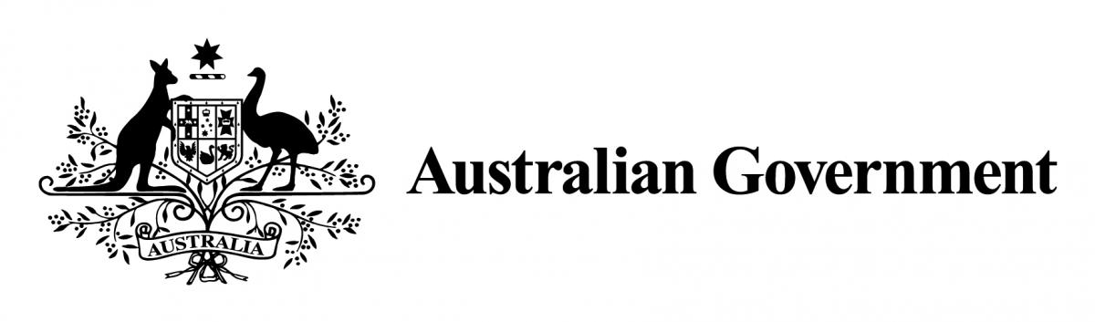
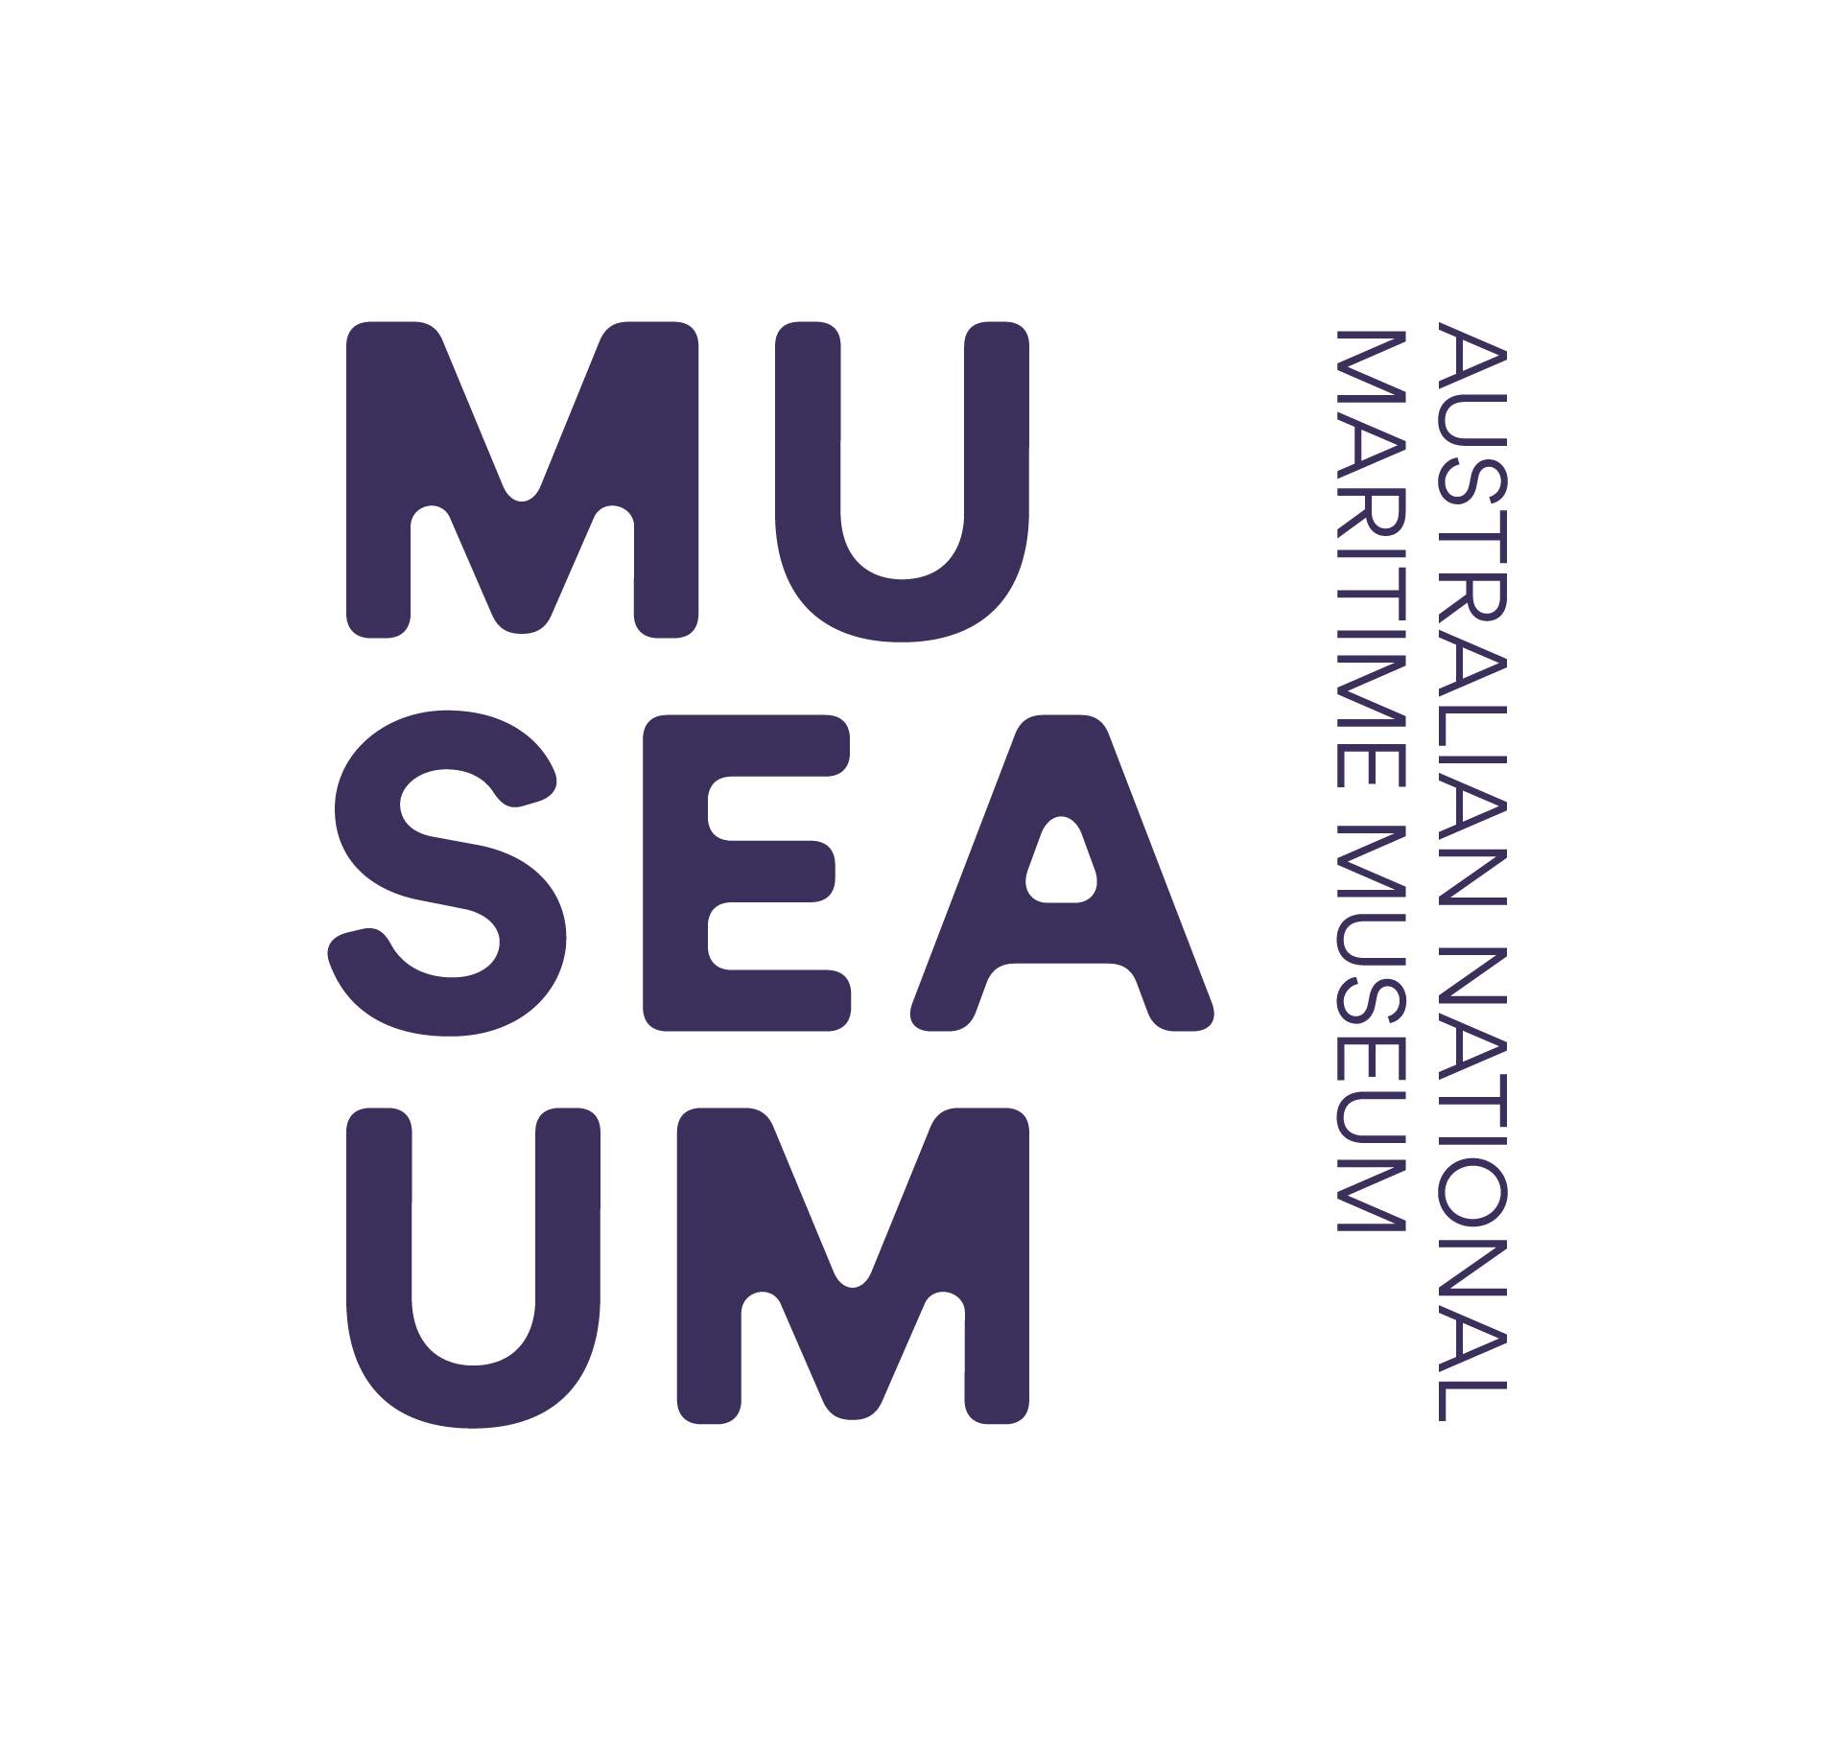

of Australia Project Support Scheme (MMAPSS)

2021 – 2022
Acquittal Template

Please use this template as a guide to completing your acquittal. As per the MMAPSS Guidelines, the final report must contain:

- a description of the project or internship as completed;
- a photographic record of the project or internship where appropriate;
- an evaluation of how the objectives of the project or internship were achieved;
- an assessment of the value of the funding to the project or internship;
- a financial acquittal statement detailing the total cost of the project or internship, how the funding was used, and details of any funding provided by other bodies;
- a publicity and media report which details formal acknowledgement of the
Australian Government and the ANMM in relation to the project, including copies of any related media coverage, web coverage or other promotional material.
- copies of any documents, media files or software commissioned under the MMAPSS grant as required in the letter of offer.

Please be sure to attach all receipts, or certified copies, related to your acquittal. Failure to do so may result in ineligibility for future funding. You may attach expanded answers or additional information to this application form.

Section 1 Organisation’s Details

1.1 | Name of organisation
1.2 | Name of President/Director
1.3 | Street address
1.4 | Postal address
1.5 | Phone number
1.6 | Email address
1.7 | Website address

Section 2 Contact Person

2.1 | Title | Dr | Mr | Mrs | Ms | Other:
2.2 | Name
2.3 | Position within the  organisation
2.4 | Email address
2.5 | Postal address
2.6 | Phone number
2.7 | Mobile phone number
2.8 | Best times to reach you?  (eg Wed-Sat, 10 am to 3 pm)
Section 3 MMAPSS Project

3.1 | What is the name of your project?
3.2 | Briefly describe your reasons for applying for funding and project objectives.
3.3 | Please tick which area your project relates to.
Collection Management (inc registration, documentation and storage)
Conservation (inc preservation, vessel restoration, conservation work/treatments and professional assessments)
Presentation (inc research, development of exhibitions, establishing interpretive displays, education programs and workshops)
Museological training for staff and/or volunteers
Education & Public Programs
3.4 | Describe the steps taken to complete your project.
Milestones
The Project milestones in your original application indicated how you were going to execute the project, the time frame you were working within and demonstrated your sound planning abilities. Please use this table to reiterate the critical tasks your project required and indicate the date each was completed.

3.4a | Project milestones table.
Project Milestone Number |  | Critical Path Tasks | Date Completed
1
2
3
4

3.5 | Explain any unexpected problems encountered.
3.6 | In what ways did you meet your overall objectives? If you did not meet your objectives, please explain why.

Section 4 Income and Expenditure

4.1 | Please list all forms of funding used to complete this project
Income |  | Amount (A$)
MMAPSS Grant
Applicant’s Contribution
Government
TOTAL
4.2 | Please list project related expenses (You must attach certified invoices and / or receipts to substantiate for the total grant expenditure).
Expenditure |  | Amount (A$)
TOTAL |  | $
4.3 | Please comment on the value of MMAPSS funding in completing your project

Section 5 Publicity and Media Report

5.1 | Describe the ways you promoted your project.
5.2 | Please list the types of media & publicity engaged for your project, i.e. print media (magazines, local papers), web coverage and other promotional material)
5.3 | Provide details of formal acknowledgement of the Australian Government and the ANMM in relation to the project. Please attach copies.

Section 6 Blog Post - Optional

Please make contact with the MMAPSS Coordinator on 02 9298 3743, or via email, if you would like to discuss and arrange a 300 – 1200 word submission for the ANMM blog www.sea.museum/discover/blog or the ANMM Website stories www.sea.museum/about/grants-and-awards/funding-for-maritime-heritage/stories.

Submissions will need to include images ideally 3MB or larger to allow for use in print media as required. If recipients would like to take the opportunity to promote their project and share their experience with other similar organisations, the blog post could detail the project or internship, provide an assessment of the value of the funding, and emphasise the long term outcomes of the project. Guidance and assistance will be given to writers of the blog post by the MMAPSS Coordinator and ANMM digital curators.

Section 7 Attachments

You must attach a financial acquittal statement and original invoices and / or receipts or certified copies of invoices and / or receipts for project costs. Please note: attachments will not be returned. Remember when justifying how the funds were spent that the receipts can only be for costs already approved when you were awarded the grant. Funds cannot be used for the payment of salaries and wages or to pay for services provided by a person who holds a position within your organisation. Funds cannot be used for the acquisition of objects and funding cannot be used for costs incurred before 1 August 2021.

Attachment | List your attachments here:
1
2
3
4
5

Section 8 Applicant Declaration

I/we, the undersigned, assure the Australian National Maritime Museum that the statements made in this acquittal are true and correct, and that I/we have read and abided by the Maritime Museums of Australia Project Support Scheme (MMAPSS) 2021 – 2022 Guidelines.

8.1 | Head of organisation.
Title |  | Dr | Mr | Mrs | Ms | Other:
Full name
Position within organisation
Date
Signature
8.2 | Contact person
Title |  | Dr | Mr | Mrs | Ms | Other:
Full name
Position within organisation
Date
Signature

All projects must be completed by 31 July 2022 and acquittals received by the Australian National Maritime Museum by 31 August 2022.

Acquittals should be addressed to:

The MMAPSS Coordinator via email to mmapss@sea.museum

OR via mail to:

Australian National Maritime Museum
58 Pirrama Road
Pyrmont NSW 2009

